React Native Docs

Intro:

React native is a framework which enables us to write javascript code to develop android and ios apps. It basically has some methods defined which gets rendered separately as per native apk or ios xapk.

It covers most of the features, but still for accessing high level native features of android/ios, we need to switch to native android/ios development.

Expo vs React Native CLI:

Expo is a tool which makes react native development fast and easy, By native cli there are two different folders for ios and android(like flutter) and both get managed by javascript code automatically.

It gives most of native features in simple manner, for some complex implementations we can switch to native cli anytime.

We get to choose workflow for our app when we init the project with expo.
Expo templates : Managed(simple js) vs Bare Workflow(it has dedicated folders ios/android)

When we do npm start, it opens up the metro bundler which is a bundlers that compiles all the javascript code to a single file.

Inside expo client we can use ctrl+M to open up developer menu.

Using expo publish we can publish the app on expo store. It will be hosted on expo.

Analogy with react:

div: View
p: Text – for all texts
onClick: onPress() - similar function inside it !
Some components(eg. Images) do not support onPress for them we wrap them in Touchables. Based on type, it also gives some animation apart from onPress attribute.
img: Image || require() - hooks can not be applied for the path directly, and for network images, there must be the dimensions, for static ones it reads from metadata.
button : Button – It is different for android and ios. The behaviour of styles is also different.
alerts : (alert – just like js alert, different for android and ios) or (Alert API – this is not a component, it allows to modify the alert box)

class : style attribute, if multiple style objects are passed it behaves like multiple classes applied to the element, the object passed are not css , they are methods which get natively applied based on values.

StyleSheet.create({}) - Normal object can also work, but this is actually a check, if invalid key is there, app will throw error, else it just works without any error and is obv not applied.

ios/android behaviour difference: We can use Platform API which helps to find which device we use. Eg Platform.OS === ‘android’ or ‘ios’

By default all elements have position set to relative, if we apply absolute, they get cut off from parent as usual.

React native site -> APIs -> Can see all capabilities of a component.

Styles:

Border:

borderWidth: 10 // gives borderWidth of 10
borderRadius: 10 // makes the edges curvy
borderLeftRadius, RightRadius etc makes the anything curvy

tip: To make the anything circular set borderRadius == half of the dimensions

Shadow:

For IOS only, Android only has elevation property:

offset is given for moving along width and height, opacity is making it noticable, actually if its zero you can not notice.
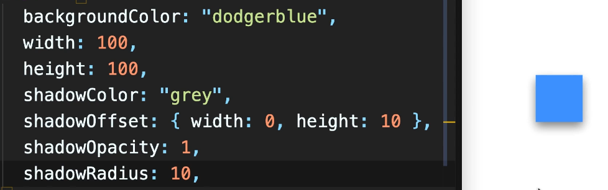

Text:

Important: ‘Font families are different for android and IOS, one font might work for android but ios it will fail and crash the app.’

fontStyle: sets the style, bold, italic etc
fontWeight: “”(MUST BE QUOTED IN STRINGS), 100 X, “100”
color: color of the font
textTransform: Will make text render as we want, eg: to capitalise each word use “ capitalize”
textAlign: default
lineHeight: spacing btw lines

Note: The text styles work only on Text tags, Even if it is applied to the parent view it won’t work. Fix by encapsulation

Encapsulating Styles:

Unlike React, react native does not supports inheritanace of styles from parents.
So we can not pass text styles at parent and enjoy, we need to do it multiple times as we use it.

Fix: Make a custom Text component, call It AppText, define its css, also we can do selective rendering of text by Platform.

If we have a button defined with styles, we want to use it across all our app, we will create AppButton.

Icons:

Icons in react native can be easily taken from expo vector-icons, it has enormous icons from everywhere!!

To use, visit expo icons site and import Icon type, using
name = pass the name of icon
size = size of the icon
color = color
Making Components Platform Specific

Since some components need different css for android and ios (eg text)

M1: we can use Platform.select method(in platform API), just define styles for ios and android separately. This returns an object depending on the platform. We can destructure to render conflicting codes
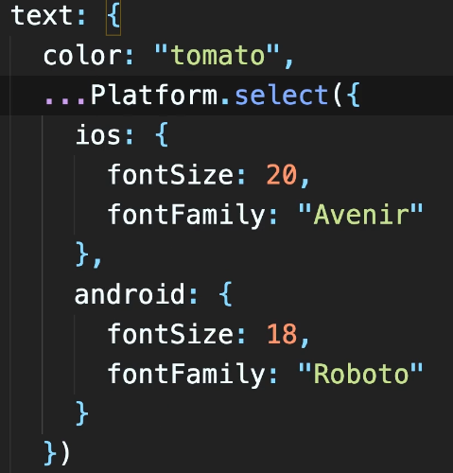

M2:
Inside components, create two components
AppText.android.js
AppText.ios.js

Define different css as required and wherever you want to use just import till AppText, dont import .android or .ios . React native will detect itself. These are case sensitive.
Button:

If we want to create custom buttons, make an AppButton component

Use TouchAbleOpacity for View
Render the title as prop
TO MAKE IT PRESSABLE WE NEED TO CREATE A PROP NAMED onPress in AppButton and pass it on onPress attribute of touchable opacity.
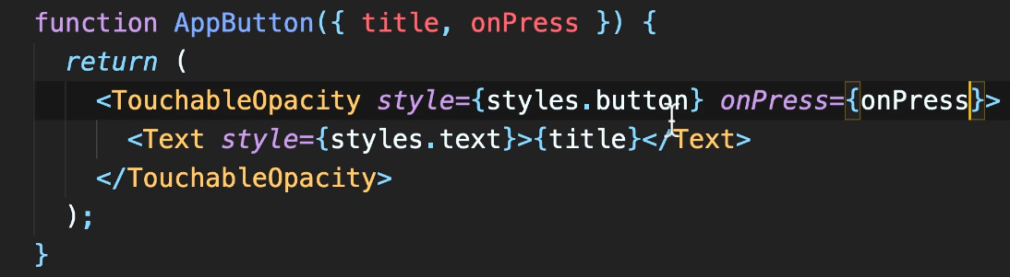

Use cases ( important ):

1. The safe area view is ios compatible, it doesn’t takes notch considerations in android, we need to add padding, in order to keep it in safe area view. The best way to find the exact height for padding is using StatusBar API, and can get height using, StatusBar.currentHeight

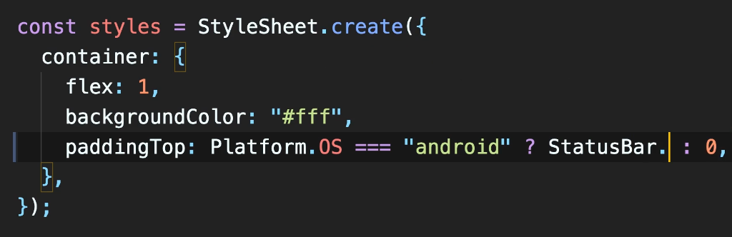

2. Dimensions – The length values specified in styles is DIPs(Density Independent Pixels). It is non relative and non absolute as it depends on scale factor as well. Output = DIP x Scale Factor(eg, 2x, 3x etc)

Using ‘10%’, percentage can ensure the relative rendering.

There is Dimension API which gives the dimensions of the screen as well as scale factor(It is the no of pixels a point has). Dimension.get(“screen” / “window”), For ios both are same, android its different.

This API is does not takes into account the orientation changes, i.e it doesn’t scale as orientation changes.

Orientations: For making the app respond differently to orientations, we need to specify orientation: default/potrait/landscape, for default it re renders the componets if device is rotated.

Now to access the new widths and heights, we need to use react-native-community/hooks package, it has: useScreeenDimensions it gives output whether its landscape or not.

3. Flexbox funda:
If we specify flexbox: 1(1- for full screen) to the parent, it makes it display flex kinda thing. The default way children are kept is vertical unlike css in web.

Inside by flexbox div:0.2/1/0.5 etc we can specify how much portion of parent children can take.

FlexDirection: column by default(mostly devices are in potrait so)
depending on flexDirection – Primary axis is decided, and |_ar to it is Secondary axis.
(Visualize and apply the following to control the alignment)
For aligning items along primary axis, justifyContent is applicable, and along secondary axis, alignItems is applicable.

If content in row exceeds screen width, things get shrinked and behave abnormally, use flexWrap: “wrap”

AlignItems takes its own behaviour when wrap is enabled, It aligns items line wise not wrt screen, when wrap is enabled, alignContent comes in action and aligns as per need.

Eg:
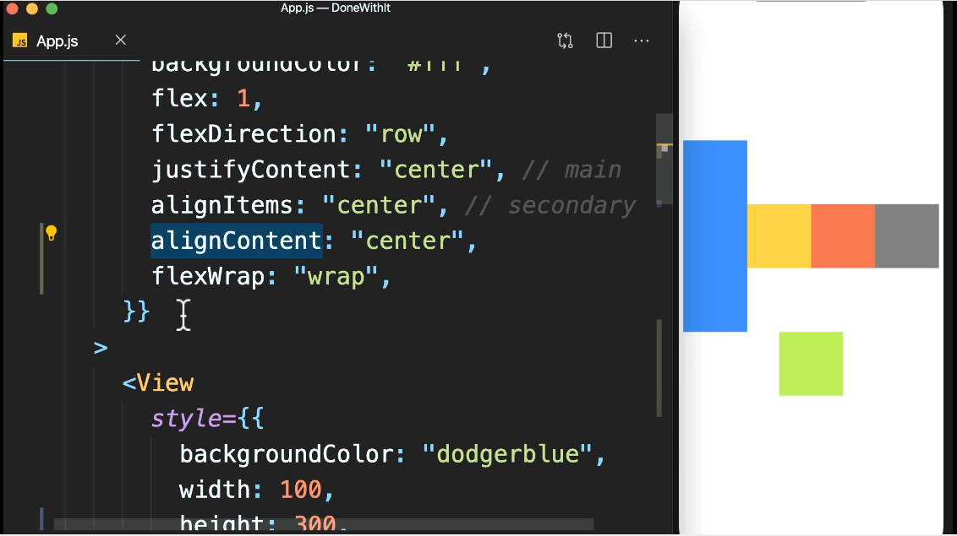

some more flex properties,

For items in flexbox:
flexBasis: 100 // depending on primary axis, it assigns the width/height
flexGrow: 1 // grows the item to cover up the remaining space
flexShrink: 1 // Incase of overflow, you allow this item to shrink in order to // make space for others
4. Folder structure

The code of the app ui is kept separate in app folder, so that whenever we decide to change other configs or import in another app, we directly shift is up.

- app
-- config
---color.js(define all colors here and import afterwards)
-- assets
--components
---AppText (App text with styles defined and it will be used everywhere)
-- screens
(name of screen components end with __Screen.js normally across devs)

Use react native snippets to import component, import bottom stylesheet.. etc

rnss – react native style sheet
rnf – react native functional component

5. Images

If we want to make an image fit a particular specified size, we need to use resizeMode: ‘contain’

